# CSCI120 - Introduction to Computer Science and Programming 1

### Quiz 2

(Chapters 3-4)

**Note:** This document has been designed and developed as part of an initiative for creating an OER (Open Education Resource) package for the course CSCI 120 at Columbia College.

Please contact [Alireza.davoodi@gmail.com](mailto:Alireza.davoodi@gmail.com) for any comment, modification, and questions.

**Terms of use:** Please feel free to customize this document as needed

Last Modified: May 2022

# Requirements

* Duration 15 min
* This is an individual quiz.
* Please do not talk to each other
* The order of the questions might be different for each students.
* Enter your answer in the answer sheet given to you.

# Problem1

* What is the result of the following code:

number = 12

while number == 12:

print(number, end="")

number = number + 5

1. 12 7 2
2. 7 2
3. 12
4. None of the above

# Problem2

* What is the result of the following code if the user enter “python”

password = input("Enter your password \n")

while password != "python":

print("Try again!")

password = input()

print("Welcome")

1. Welcome
2. Try again!
3. Enter your password
4. Some error will happen

# Problem3

* In the following code how many times it is going to print Koinonia? (if the user enters 15, as shown)

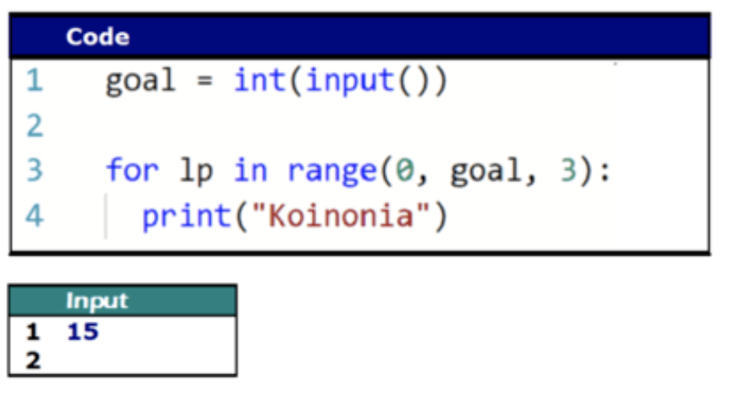

1. 15
2. 3
3. 6
4. 5

# Problem4

* What is printed on the screen by the code below:

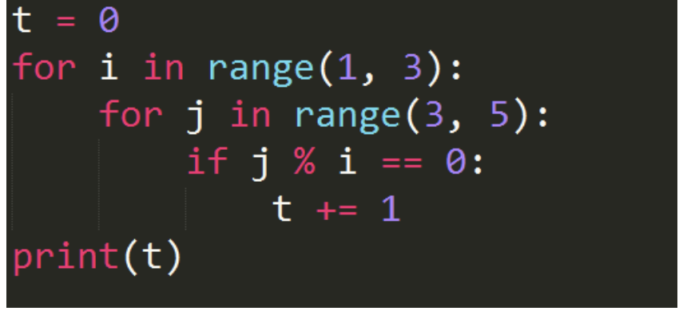

1. 0
2. 1
3. 2
4. 3

# Problem5

* Which code will print the following output?

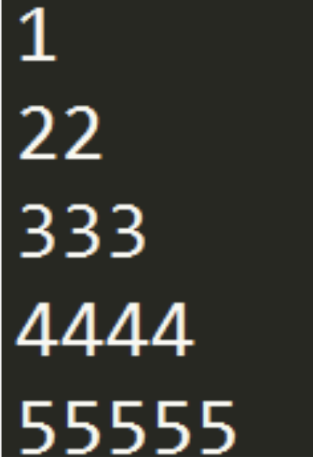

1. for i in range(1, 5):     
    print(str(i) * 5)
2. for i in range(1, 5):     
    print("i" * i)
3. for i in range(1, 6):     
    print("i" * i)
4. for i in range(1, 6):     
    print(str(i) * i)

# Problem6

* What is the result of the following code?

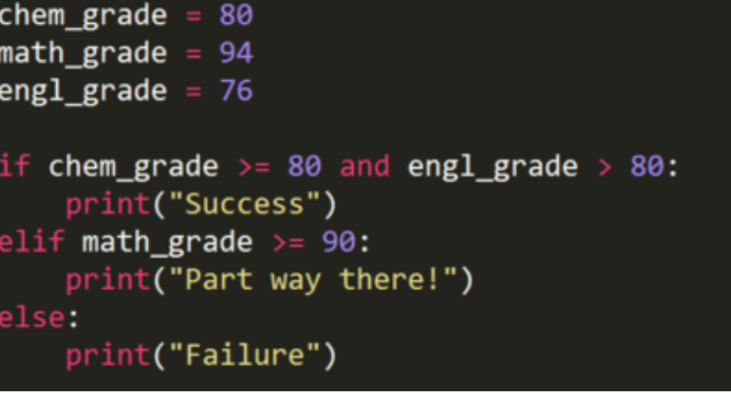

1. Success
2. Failure
3. Part way there!
4. No output will be printed

# Problem7

* Which of the following inputs will lead to no output to be printed for the following code:

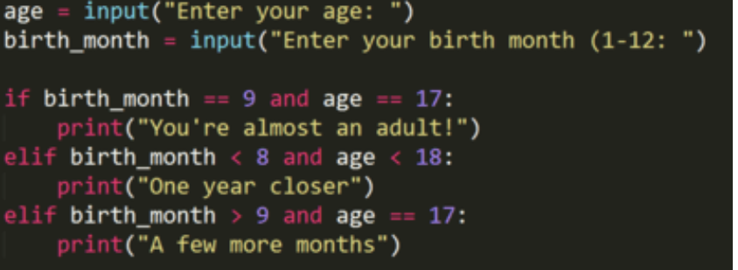

1. age is 17 and birth_month is 8
2. age is 16 and birth_month is 7
3. age is 17 and birth_month is 10
4. age is 12 and birth_month is 4

**Good Luck ☺**